SOFTWARE ENGINEERING PROJECT

on

**Destination Rooms- An Online Hotel Room Booking System**



**Submitted by:-**

**Ankit Kumar Chinmay Jain**

**(16KEMVBSCS00021) (16KEMVBSCS00069)**

**Chirag Mittal Hikansh Kapoor (16KEMVBSCS00014) (16KEMVBSCS00028)**

DEPARTMENT OF COMPUTER SCIENCE

KESHAV MAHAVIDYALAYA

University of Delhi

ACKNOWLEDGEMENT

It is our privilege to express our sincerest regards to our project supervisor, Mr. Sumit Aggarwal, for his valuable inputs, able guidance, encouragement, whole-hearted cooperation and constructive criticism throughout the duration of our project.

We deeply express our sincere thanks to our Head of Department Mrs. Vinita Jindal for encouraging and allowing us to present the project on the topic **“Destination Rooms- An Online Hotel Room Booking System”** at our department premises for the partial fulfillment of the requirements leading to the award of B.Sc. degree.

We take this opportunity to thank all our lecturers who have directly or indirectly helped us in our project. We pay our respects and love to our parents and all other family members and friends for their love and encouragement throughout our career. Last but not the least we express our thanks to our friends for their cooperation and support.

CERTIFICATE

This is to certify that Software Engineering project report entitled “**Destination Rooms- An Online Hotel Room Booking System**” is the work carried out by Ankit Kumar, Chinmay Jain, Chirag Mittal, Hikansh Kapoor, students of B.Sc.(H) Computer Science 4th Semester, Keshav Mahavidyalaya, University of Delhi under the supervision of Mr.Sumit Aggarwal, Mr. Anand, Mrs. Disha Garg and Mrs. Vinita Jindal. This report has not been submitted to any other organization/institution for the award of any other degree/diploma.

Supervisor Teacher In-charge Principal

(Mr Sumit Aggarwal) (Mrs Vinita Jindal) (Dr. Madhu Pruthi)

Abstract

In today's technology era, IOT (Internet of things) has become much popular around the world. Almost all the devices, which are known as smart device, can connect with the internet and access data from any corner of the world. There was a time when people used to waste their valuable times just to get a piece of information. Now the technology is more advance then compare to ancient times. One of the blessings of technology is web application. It allows users to interact with the system from anywhere as long as they are connected to the internet.

This report presents the project work "Destination Rooms – An Online Hotel Room Booking System" that is a web application.

As we already discussed above that internet has made the user’s interaction through the system easier, so this web application can connect to respective servers for accessing data, which will surely help users to book his/her room at desired location and at desired timings.

Moreover, in recent days people like to travel to get some relief from their monotonous life. So, they can travel without any hesitations. In this modern technology era they are in need of system that will enhance the portability, accessibility as well as that is user friendly. Therefore, we propose a web based system that resolves all the problems stated above and having all the features that will make it more user friendly and accessible. The aim of this project is to develop a system that would help different hotel owners to manage their data.

Creation of Online hotel room booking project is the slice unit which also target that public who want different facilities in room such as meals and WIFI. This was conceptualized precisely for people on the go. Anyone directly can register with this then the admin will treat the customers according to their demand. So at that time onwards the user directly can login into this and he/she can get the facilities according to his/her choice. Through this project we are providing more user interaction. It is having mainly two modules. One is at Administration Level and other one is of user. The Application maintain authentication in order to access the application. Administrator task includes managing hotel and room information. To achieve this aim a database was designed in order to allow the admin to access his/her hotel information and update according to his/her strategies and can store all time information about his/her guest and customer.

With the advent of computer technology and the internet, users prefer to conduct their business electronically to their convenience. This paper focuses on the need and construction to provide comfort and ease to the user.

**List of Figures:-**

|  |  |
| --- | --- |
| **Figures** | **Page No.** |
| * Fig1.3.1 DFD Level-0 | 5 |
| * Fig 1.3.2 DFD Level-1 | 6 |
| * Fig 1.3.3 DFD Level-2 | 6 |
| * Fig2.3.1 Gantt Chart | 15 |
| * Fig3.1 Architectural Design | 16 |
| * Fig 5.1 Signup | 23 |
| * Fig 5.2 Login | 26 |
| * Fig 5.3.1 First Page | 31 |
| * Fig 5.3.2 Book Rooms | 37 |
| * Fig 5.4 Home Page | 49 |
| * Fig 6.2.1 Program Flow Graph | 51 |
| * Fig 6.2.2 Program Flow Graph | 54 |
| * Fig 6.2.3 Program Flow Graph | 57 |

**List of Tables:-**

|  |  |
| --- | --- |
| **Tables** | **Page No.** |
| * Table 2.1 Complexity Table | 12 |
| * Table 4.2.3 Risk Estimation Table | 18 |
| * Table 4.2.4.1RiskInformation Sheet | 19 |
| * Table4.2.4.2Risk Information Sheet | 20 |

Table of Contents

CHAPTER 1 **SRS (Software Requirement Specification)**

1.1 Introduction……………………………………………………………………….….1

1.1.1 Purpose……………………………………………………………………………….……………………………..…1

1.1.2 Document Conventions……………………………………………………….………………………………..1

1.1.3 Intended Audience & Reading Suggestions………………………….…………..……………..…….1

1.1.4 Project Scope……………………………………………………………………….………………………………..2

1.1.5 Reference………………………………………………………..……………………..……………………………..2

1.2 Overall Description…………..……………………………………..…………....2

1.2.1 Product Perspective…………………………………………..…………………….…………………..………..2

1.2.2 Product Features……………………………………………………………………….……………….………….2

1.2.2.1 Core Feature…………………………..……………………………………………………..…………………………………2

1.2.2.2 Additional Feature………………………………………………………….…………………………………………………2

1.2.3 User Classes & Characteristics………………….……………………………….…………..…..………….3

1.2.4 Operating Environment………………………………….………………………….…………………………..3

1.2.5 Design & Implementation Constraints…………….……………………………………..………….....4

1.2.6 User Documentation……………………………………………………………………………………………..4

1.2.7 Assumption & Dependencies…………………………………………………………………..…………….4

1.3 DFD…………….………………………………………………………….……………..5

1.3.1 Level-0……………………………………………………………………………………………………….…..………5

1.3.2 Level-1……………………………………………………………………………………………………….…..………5

1.3.3 Level-2……………………………………………………………………………………………………….…..………6

1.4 DD……………………………………………………………….…………………….....6

1.5 External Interface Requirements………………….…………………….....6

1.5.1 User Interface…………………………………………………………………………………………………………7

1.5.2 Hardware Interface………………………………………….…………………………………………………….

1.5.3 Software Interface………………………………………………………………………………………………….7

1.5.4 Communications Interface……………………………….…………………………………………………….7

1.6 System Features……………………………………………..…………………….7

1.6.1 System Features ………………………………………………………………………………………..…..…..…7

1.6.1.1 Description & Priority………………….………………………………………………………………………...……......8

1.6.1.2 Stimulus/Response Sequences……………………………………………………………………………….....……..8

1.6.1.3 Functional Requirements…………………………………………………………………………………………..………8

1.7 Other Non-functional Requirements….…………………………..….....8

1.7.1 Performance Requirements…………………………………………………………………….………………8

1.7.2 Safety Requirements…..………………………………………………………………………….……………….8

1.7.3 Security Requirements…………………………………….…………………………………….………………..9

1.7.4 Software Quality Attributes…………………………….…………………………………….….………….…9

1.8 Other Requirements………………………………………………………………………………………9

1.8.1 Capacity Requirements…………………………………………………………………………………………...9

1.8.2 Availability Requirements………………………………………………………………………………..........9

CHAPTER 2 **Estimation and Scheduling**

2.1 Size Estimation……………………………………………………………………….10

2.2 Cost Estimation………………………………………………………………………12

2.3 Gantt Chart……………..…..…………………………………………………………14

CHAPTER 3 **Architectural Design**

3.1 Design………………………………………………………………….…………………..15

CHAPTER 4 **Risk Management**

4.1 Introduction……….………………………………..………….…..…..16

4.2 Risk Management Procedure……………………………….....………………..17

4.2.1 Process…………………………………………………………………………………………………….……..17

4.2.2 Risk Identification………………………………………………………….……………………………….18

4.2.2 Risk Estimation…..……………………………………………………….……………………………….18

4.2.2 RMMM Plan ………………………………………………………………………………...................19

CHAPTER 5 **Implementation**

5.1 Signup.php File………..…………………………………………………..………….21

5.2 Login.php File …………………………………………….……………………………24

5.3 Index.php File ……….………………………………………….…….………………27

5.4 Bookrooms.php File……….………………………………………………………..32

5.5 Final.php File…………………………………………………………………………….38

CHAPTER 6 **Testing**

6.1 White Box Testing……………..………………………..……….……...............51

6.2 Program Flow graph………..……………….………………………….…………52

6.3 Independent Paths………………………………….………………………………59

CHAPTER 7 **User Manual**

7.1 Steps of using the system………………….……..…….………………………60

CHAPTER 8. **Conclusion**

8.1 Conclusion ……………………………….………….……….…………61

**References 61**

1. Software Requirement Specification (SRS)

# Introduction

## 1.1.1 Purpose

This Software is developed to provide the online facilities to the people who are willing to book hotel-rooms in advanced.

## Document Conventions

-> Headings and sub-headings are written in bold letters using “Arial Rounded MT Bold” and "Times" font respectively.

->Descriptions are written in "Calibri" font.

## Intended Audience and Reading Suggestions

This Document is intended for the users, clients and developers as a reference of the final product delivered at the end of the project.

Reading Sequence:-

1. Introduction

2. Overall Description

3. External Interface requirements

4. System Features

5. Other Nonfunctional Requirements

6. Other Requirements

## Product Scope

This software can provide benefits to the users willing to book hotel-rooms by the means of online sources. The basic goal of this software is to provide digitalization and ease of booking rooms at several locations and hotels in our country.

## References

**Books References:**

[1] R.S.Pressman,Software Engineering,McGraw-Hill,Ed 7,2010.

[2] P.Jalote, An Integrated Approch to Software Engineering,Ed.3,2011.

[3] Elmasri Navathe, *Fundamentals of Database System 3rd edition*. Pearson education,2000.

# Overall Description

## Product Perspective

This is a self-contained product newly produced by our company.

## Product Functions

Major functions that this software lets the user perform :-

1. Search for hotels in a particular area.

2. Book rooms over the internet.

Major functions that this software lets the admin perform :-

1. Checking and confirming the booking that user made.

2. Updates the information about the hotel.

## User Classes and Characteristics

We have made this product to be extremely "User-Friendly in terms of usage and other details but we expect the user to have a basic knowledge of the following things:-

1. User must understand English Language.

2. User must know how to use a Smartphone.

3. User must be able to handle the online payment gateways or have a little knowledge about how to make an online payment.

Except these no other Technical/Educational Expertise is required from the user end.

## Operating Environment

The software runs on Windows Operating System.

## Design and Implementation Constraints

Minimum Requirements for the software:-

Windows Users:-

Minimum OS Version:- win7

Minimum Storage:- 500 MB

Minimum RAM:- 2GB

Minimum Processor:-Intel i3

## User Documentation

User Manual would be provided along with the software as a README file. User guide would be provided with the documentation itself.

## 1.2.7 Assumptions and Dependencies

Some software used in implementing the system is with high cost and the client has agreed to afford the amount of money needed to purchase them. It’s assumed that client won’t change that decision on the next phases of the software development. Although we assume that client is using windows 7 or above. Otherwise if client use an open source operating system, there is a need of changing the SRS accordingly.

* 1. **Data Flow Diagram (DFD):**
     1. **Level-0**

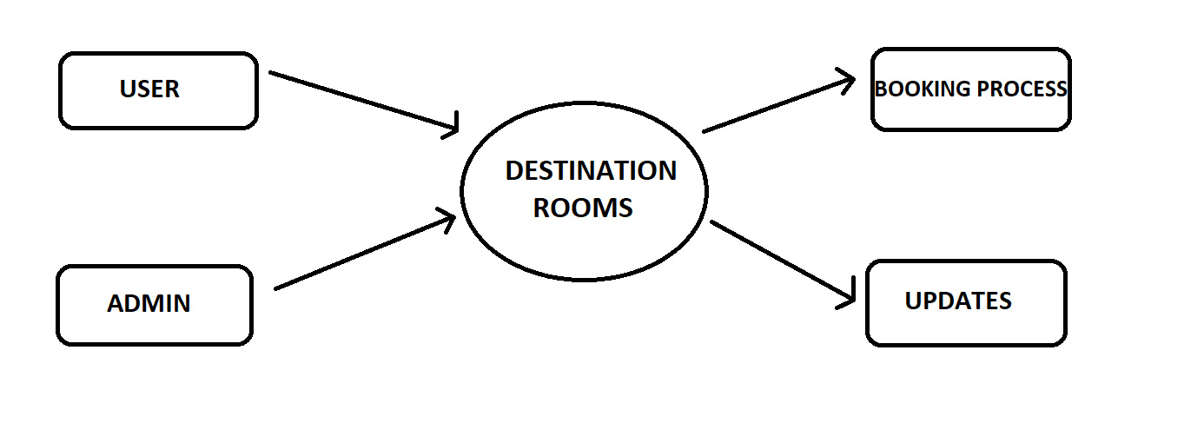

**Fig 1.3.1 DFD Level 0**

* + 1. **Level 1:**

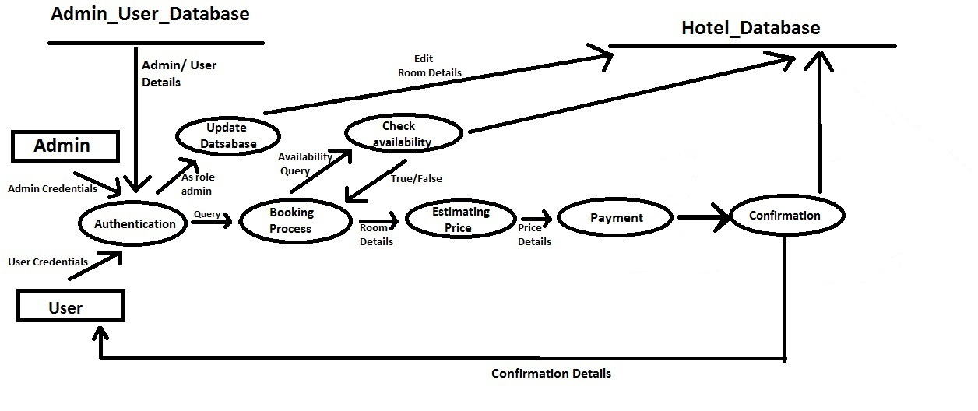

**Fig 1.3.2 DFD Level 1**

* + 1. **Level-2**

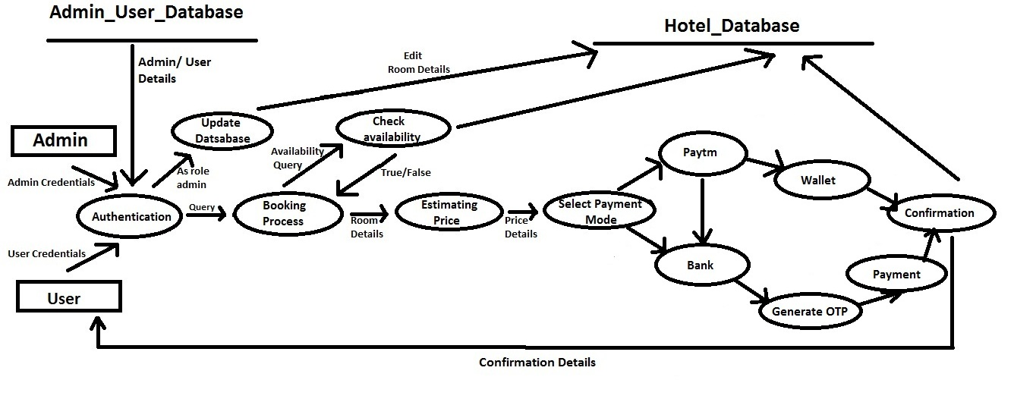

**Fig 1.3.3 DFD Level 0**

**1.4 Data Dictionary (DD):**

* **Query:-** Hotel name and location/hotel features.
* **Availability Query:-** Arrival and departure date, No. of rooms and room type
* **Room Details:-** Room facilities.
* **Price Details:-**  Room details and total amount
* **Confirmation details:-** Receipt(Mode of payment, date, time ,type, room details)
* **Edit Room Details:**- Hotel info and facilities

# External Interface Requirements

## User Interfaces

The user interface for system shall be compatible to any type of web browser such as Mozilla Firefox, Google Chrome and Internet Explorer.

## Hardware Interfaces

Booking alerts will be sent to the one of the member of hotel staff as an e-mail notification. So there is a need of broadband internet connection. Client should able to keep a stable internet connection.

## Software Interfaces

**Web Server**

• Apache Tomcat Server, OS (Windows)

**Database Server**

• Mongo DB, OS (Windows)

**Development End**

• Node.JS , PHP, Java , HTML ,XML, JavaScript, OS(Windows)

## Communications Interfaces

The System shall be using HTTP/HTTPS for communication over Internet and for intranet communications, it shall use TCP/IP protocol.

# 1.6 System Features

The System provides the basic facility to the users to book the hotel rooms through online mode.

## Fast and Reliable Online Process

## 1.6.1.1 Fast Booking Process

## One can book the rooms as quick as swiping some screens here and there and confirming the payment.

**1.6.1.2 Functional Requirements**

* Make Bookings
* Search Rooms
* Add Payment
* Issue Bills
* Manage Guest (Add, Update Guest)
* Manage Room Details (Add, Update, Delete)
* Set Rates
* Manage Users (Add, Update, Delete)
* Taking Backups
* *E*-mail notifications

# Other Nonfunctional Requirements

## Performance Requirements

* Data in database should be updated within 2 seconds.
* Query results must return results within 5 seconds
* Load time of UI Should not take more than 2 seconds
* Login Validation should be done within 3 seconds
* Response to customer inquiry must be done within 5 minutes.

## Safety Requirements

There are several user levels in hotel management system, Access to the various subsystems will be protected by a user log in screen that requires a user name and password. This gives different views and accessible functions of user levels through the system. Maintaining backups ensure the system database security. System can be restoring in any case of emergency.

## Security Requirements

* All external communications between the data’s server and client must be encrypted
* All data must be stored, protected or protectively marked.
* Payment Process should use HTTP Secure protocol to secure the payment transactions

## Software Quality Attributes

* **Correctness**: This system should satisfy the normal regular Hotel Management operations precisely to fulfill the end user objectives
* **Efficiency:** Enough resources to be implemented to achieve the particular task efficiently without any hassle.
* **Flexibility**: System should be flexible enough to provide space to add new features and to handle them conveniently
* **Integrity:** System should focus on securing the customer information and avoid data losses as much as possible
* **Portability:** The system should run in any Microsoft windows environment.
* **Usability:** The system should provide user manual to every level of **users**.
* **Testability:** The system should be able to be tested to confirm the performance and clients specifications.
* **Maintainability:** The system should be maintainable.

# Other Requirements

**1.8.1 Capacity Requirements**

* Not more than 10,000 members to be registered.
* System need to handle at least 20 transactions during peak hours.

**1.8.2 Availability Requirements**

Report should be generated automatically every day for manager and anytime upon request.

1. Estimation and Scheduling
   1. Size Estimation

**Software sizing** is an activity in software engineering that is used to determine or estimate the size of a software application or component in order to be able to implement other software project management activities (such as estimating or tracking). Size is an inherent characteristic of a piece of software just like weight is an inherent characteristic of a tangible material.

We have categorized external inputs on subfields

If <3-Simple Complexity

<4-Medium Complexity

>=4-High Complexity

For external output

1 detail-Simple Complexity

2 detail-Medium Complexity

>2 detail-High Complexity

We take all logical fields as well as external enquiry as simple

External Inputs

1. Login credential=>Name, Password (medium)

2. Sign up credential=>I’d, Name, Phone number, Password (complex)

3. Admin login=>Name, Password, Key (medium)

4. General Details=> Location, Arrival Date, Departure Date (medium)

5. Room Details=> Number of rooms (simple)

External Outputs

1. Search Result=>Hotels (simple)
2. Before Booking=> Order Summary(simple)
3. Booking Result=> Fares, Confirmation details(medium)

Logical internal files (all simple)

1. User Login

2. User Signup

3. Admin Login

4. Search a hotel

5. Book the room

6. Order Summary and User Confirmation

7. Payment

8. Final Booking Receipt

External interface files

1. Paytm Gateway
2. Bank Authentication

External enquiries

1. Hotel details (result)

2. Room details (result)

|  |  |  |  |
| --- | --- | --- | --- |
|  | Simple | Medium | High |
| External I/P | 1 | 3 | 1 |
| External O/P | 2 | 1 | 0 |
| Logical Interface | 8 | 0 | 0 |
| External Interface | 2 | 0 | 0 |
| External Enquiry | 2 | 0 | 0 |

Table 2.1 Complexity Table

UFP (Unadjusted Function Point) =1X3+3X4+1X6+2X4+1X5+8X7+2X5+2X3

=3+12+6+8+5+56+10+6

=106

Assuming complexity adjustment factor as average

CAF=0.65+0.01X14X3

=1.07

File Point= UFP X CAF

=106 X 1.07

= 113.42

=114(approx)

2.2 Cost Estimation

The cost of software is mainly from developer time, but can also be from training, managing and buying extra equipment, servers and software. Many methods have been developed for estimating software costs for a given project.

Screens-8

Reports-3 (2 simple, 1 average)

3GL-0

Object Point=8X2+2X5+1X5

=16+10+5

=31

NOP (New Object Point) = Object Point X (1-reuse)

= 31 X (1-0)

= 31

Efforts = NOP/PROD

=31/13

=2.38

NOP= New Object Point

PROD= Productivity

We have assume nominal developer experience

2.3 Gantt Chart

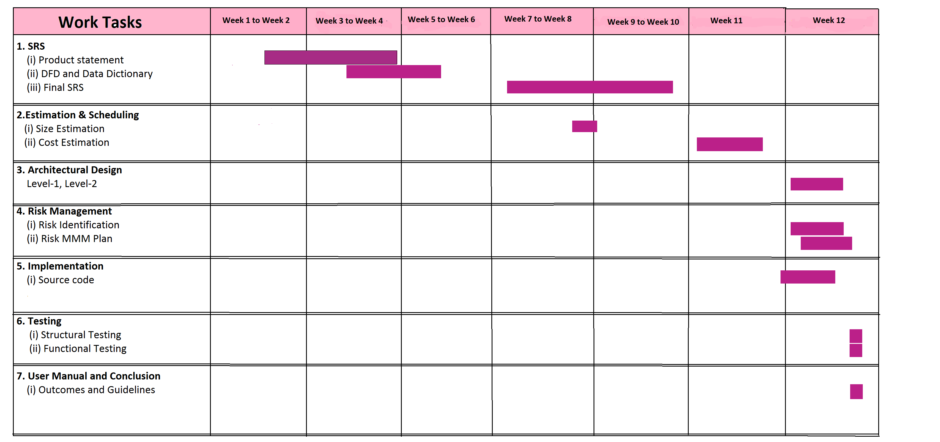

Fig 2.3.1 Gant Chart

1. Architectural Designs

**LOGIN**

**USER**

**ADMIN**

Access Database

Room Booking

Date

Location

Hotel Room

Make Payment

Fig 3.1 Architectural Design

Make Payment

FOR USER :

ROOM BOOKING : This field is for user to begin the booking process.

LOCATION/DATE : By this field user can select desired location and date.

HOTEL ROOM : This field allows user to select available hotel rooms according to his choice.

MAKE PAYMENT : This field is for user to make payment for room.

FOR OWNER:

ACCESS DATABASE : This allows owner to access hotel database where all the expenses, room details etc. are kept and updated according to the bookings.

1. Risk Management

# 

# 4.1 INTRODUCTION

## Purpose

A risk is an event or condition that, if it occurs, could have a positive or negative effect on a project’s objectives. Risk Management is the process of identifying, assessing, responding to, monitoring, and reporting risks. This Risk Management Plan defines how risks associated with the *Online Hotel Room Booking System* project will be identified, analyzed, and managed. It outlines how risk management activities will be performed, recorded, and monitored throughout the lifecycle of the project and provides templates and practices for recording and prioritizing risks.

The Risk Management Plan is created by the project manager in the Planning Phase and is monitored and updated throughout the project.

# 4.2 Risk Management Procedure

## 4.2.1 Process

The project manager working with the project team will ensure that risks are actively identified, analyzed, and managed throughout the life of the project. Risks will be identified as early as possible in the project so as to minimize their impact. The steps for accomplishing this are outlined in the following sections.

## 4.2.2 Risk Identification

Risk identification will involve the project team members and will include an evaluation of environmental factors, organizational culture and the project management plan including the project scope. Careful attention will be given to the project deliverables, assumptions, constraints, cost/effort estimates, resource plan, and other key project documents. Therefore we have identified the following risks:-

* Database crash
* Software Hacking
* Staff turnover will be high
* Delivery deadline will be tightened

## 4.2.3 Risk Estimation

*Risk projection*, also called *risk estimation,* attempts to rate each risk in two ways—

(1) The likelihood or probability that the risk is real and

(2) The consequences of the problems associated with the risk, should it occur. You work along with other managers and technical staff to perform four risk projection steps:

1. Establish a scale that reflects the perceived likelihood of a risk.
2. Identify the consequences of the risk.
3. Estimate the impact of the risk on the project and the product.
4. Assess the overall accuracy of the risk projection so that there will be no misunderstandings.

|  |  |  |
| --- | --- | --- |
| **Risks** | **Probability** | **impact** |
| Database crash | 20% | 1 |
| Software Hacking | 10% | 2 |
| Staff turnover will be high | 40% | 3 |
| Delivery deadline will be tightened | 50% | 2 |

Table 4.1 Risk Estimation Table

**Impact values:**

**1—catastrophic**

**2—critical**

**3—marginal**

**4—negligible**

## 4.2.4 The RMMM Plan

A separate risk mitigation, monitoring, management plan for each major risk will be assigned to a project team member for monitoring purposes to ensure that the risk will not “fall through the cracks”. The RMMM plan for each major risk would be stated by a RIS (Risk Information Sheet).

Major Risks:

1. Database Crash
2. Software Hacking

|  |
| --- |
| **RISK INFORMATION SHEET** |
| **RiskID:ROP-43 Date:3/15/18 Prob:20% Impact: Catastrophic** |
| **Description:**  Database Crash means that our databases to responding to commands from  Users and is unable to fetch data for the same. |
| **Refinement/Context:**   * The server of the Database provider is not working properly. * The database location is ambiguous. * No.of users exceeds the limit. |
| **Mitigation/Monitoring:**  To avoid such situations, Backup of data is taken everyday. We can make a simple  Routine to backup our data at a particular time in the morning and in the evening as  well. |
| **Management:**  As soon as the Database Crashes we can restore data from recent backup and  provide our users the same experience again. |
| **Current Status:**  Not yet occurred. |
| Assigned: |

Table 4.2 Risk Information Sheet

|  |
| --- |
| **RISK INFORMATION SHEET** |
| **RiskID:ROP-44 Date:3/20/18 Prob:10% Impact:Catastrophic** |
| **Description:**  Software Hacked means some hacker get unauthorised access of our data. |
| **Refinement/Context:**  The security company that we hired was unable to provide quality services. |
| **Mitigation/Monitoring:**  To enhance the security of our product we can hire some internet security  Companies to secure our software product from malicious attacks. |
| **Management:**  We have to hire ethical hackers who could help us to deal with the problem. |
| **Current Status:**  Not yet occurred. |
| Assigned: |

Table 4.3 Risk Information Sheet

1. **Implementation**

5.1 SignUp.php

<!doctype html>

<html lang="en">

  <head>

    <!-- Required meta tags -->

    <meta charset="utf-8">

    <meta name="viewport" content="width=device-width, initial-scale=1, shrink-to-fit=no">

    <!-- Bootstrap CSS -->

    <link rel="stylesheet" href="<https://maxcdn.bootstrapcdn.com/bootstrap/4.0.0/css/bootstrap.min.css>" integrity="sha384-Gn5384xqQ1aoWXA+058RXPxPg6fy4IWvTNh0E263XmFcJlSAwiGgFAW/dAiS6JXm" crossorigin="anonymous">

    <title>SignUp</title>

  </head>

  <body>

    <!-- Optional JavaScript -->

    <!-- jQuery first, then Popper.js, then Bootstrap JS -->

    <script src="<https://code.jquery.com/jquery-3.2.1.slim.min.js>" integrity="sha384-KJ3o2DKtIkvYIK3UENzmM7KCkRr/rE9/Qpg6aAZGJwFDMVNA/GpGFF93hXpG5KkN" crossorigin="anonymous"></script>

    <script src="<https://cdnjs.cloudflare.com/ajax/libs/popper.js/1.12.9/umd/popper.min.js>" integrity="sha384-ApNbgh9B+Y1QKtv3Rn7W3mgPxhU9K/ScQsAP7hUibX39j7fakFPskvXusvfa0b4Q" crossorigin="anonymous"></script>

    <script src="<https://maxcdn.bootstrapcdn.com/bootstrap/4.0.0/js/bootstrap.min.js>" integrity="sha384-JZR6Spejh4U02d8jOt6vLEHfe/JQGiRRSQQxSfFWpi1MquVdAyjUar5+76PVCmYl" crossorigin="anonymous"></script>

<nav class="navbar navbar-expand-md navbar-light" style="background-color:wheat;color:white;">

  <button class="navbar-toggler navbar-toggler-right" type="button" data-toggle="collapse" data-target="#navbarNavAltMarkup" aria-controls="navbarNavAltMarkup" aria-expanded="false" aria-label="Toggle navigation">

    <span class="navbar-toggler-icon"></span>

  </button>

  <a class="navbar-brand" href="#">Questions App</a>

  <div class="collapse navbar-collapse" id="navbarNavAltMarkup">

    <div class="navbar-nav">

      <a class="nav-item nav-link" href="Questions.php">Questions</a>

      <a class="nav-item nav-link" href="login.php">Sign In</a>

      <a class="nav-item nav-link current" href="signup.php">Sign Up</a>

    </div>

  </div>

</nav>

<br>

<div class="container">

<h2 style="text-align:center;" class="display-3">SignUp</h2>

<br><hr>

  <div class="row justify-content-center">

    <div class="col-md-6">

      <form action="signup.php" method="POST">

    <label>Email address</label>

    <input type="email" class="form-control" name="uname" placeholder="E-mail" required>

<br>

    <label>Mobile Number</label>

    <input type="text" class="form-control" name="mobno" placeholder="Mobile Number" required><br>

    <label>City</label>

    <input type="text" class="form-control" name="city" placeholder="City" required><br>

    <label>Password</label>

    <input type="password" class="form-control" name="pwd" placeholder="Password" required>

<!--  <div class="checkbox">

    <label>

      <input type="checkbox"> Remember me

    </label>

  </div>-->

  <br>

  <button type="submit" name="btn2" class="btn btn-primary">Submit</button>

</form>

    </div>

  </div>

</div>

  </body>

</html>

<?php

if(isset($_POST['btn2']))

{

if(isset($_POST['uname'])&&!empty($_POST['uname'])&&isset($_POST['pwd'])&&!empty($_POST['pwd']))

{

$u=$_POST['uname'];

$p=$_POST['pwd'];

$f=1;

$str="\n".$u.":".$p;

$handle=fopen("user_crs.txt","a+");

while(!feof($handle))

{

$s=fgets($handle);

$a=explode(':',$s);

if(($u==trim($a[0])))

{

$f=0;

echo "<br><div class='container'><div class='alert alert-danger'>Email Already in Use..Try Again</div></div>";

break;

}

}

if($f==1)

{

fwrite($handle,$str);

header("Location:login.php");

}

fclose($handle);

}

}

?>

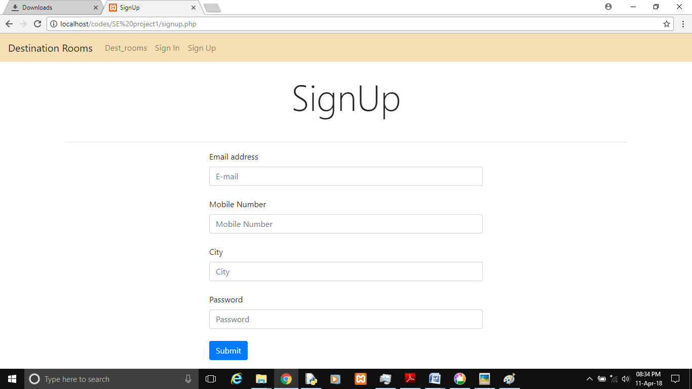

Fig 5.1 Signup

5.2 Login.php

<?php

  session_start();

  ?>

<!doctype html>

<html lang="en">

  <head>

    <!-- Required meta tags -->

    <meta charset="utf-8">

    <meta name="viewport" content="width=device-width, initial-scale=1, shrink-to-fit=no">

    <!-- Bootstrap CSS -->

    <link rel="stylesheet" href="<https://maxcdn.bootstrapcdn.com/bootstrap/4.0.0/css/bootstrap.min.css>" integrity="sha384-Gn5384xqQ1aoWXA+058RXPxPg6fy4IWvTNh0E263XmFcJlSAwiGgFAW/dAiS6JXm" crossorigin="anonymous">

    <title>Login</title>

  </head>

  <body>

    <!-- Optional JavaScript -->

    <!-- jQuery first, then Popper.js, then Bootstrap JS -->

    <script src="<https://code.jquery.com/jquery-3.2.1.slim.min.js>" integrity="sha384-KJ3o2DKtIkvYIK3UENzmM7KCkRr/rE9/Qpg6aAZGJwFDMVNA/GpGFF93hXpG5KkN" crossorigin="anonymous"></script>

    <script src="<https://cdnjs.cloudflare.com/ajax/libs/popper.js/1.12.9/umd/popper.min.js>" integrity="sha384-ApNbgh9B+Y1QKtv3Rn7W3mgPxhU9K/ScQsAP7hUibX39j7fakFPskvXusvfa0b4Q" crossorigin="anonymous"></script>

    <script src="<https://maxcdn.bootstrapcdn.com/bootstrap/4.0.0/js/bootstrap.min.js>" integrity="sha384-JZR6Spejh4U02d8jOt6vLEHfe/JQGiRRSQQxSfFWpi1MquVdAyjUar5+76PVCmYl" crossorigin="anonymous"></script>

<nav class="navbar navbar-expand-md navbar-light" style="background-color:wheat;color:white;">

  <button class="navbar-toggler navbar-toggler-right" type="button" data-toggle="collapse" data-target="#navbarNavAltMarkup" aria-controls="navbarNavAltMarkup" aria-expanded="false" aria-label="Toggle navigation">

    <span class="navbar-toggler-icon"></span>

  </button>

  <a class="navbar-brand" href="#">Questions App</a>

  <div class="collapse navbar-collapse" id="navbarNavAltMarkup">

    <div class="navbar-nav">

      <a class="nav-item nav-link" href="Questions.php">Questions</a>

      <a class="nav-item nav-link" href="login.php">Sign In</a>

      <a class="nav-item nav-link" href="signup.php">Sign Up</a>

    </div>

  </div>

</nav>

<br>

<div class="container">

<h2 style="text-align:center;" class="display-3">Login</h2>

<br><hr>

  <div class="row justify-content-center">

    <div class="col-md-6">

      <form action="login.php" method="POST">

    <label>Email address/Username</label>

    <input type="email/text" class="form-control" name="uname" placeholder="E-mail/Username" required>

<br>

    <label>Password</label>

    <input type="password" class="form-control" name="pwd" placeholder="Password" required>

<!--  <div class="checkbox">

    <label>

      <input type="checkbox"> Remember me

    </label>

  </div>-->

  <br>

  <button type="submit" name="btn" class="btn btn-primary">Submit</button>

</form>

    </div>

  </div>

</div>

  </body>

</html>

<?php

if(isset($_POST['logout'])){

session_destroy();

header("Location:login.php");

}

else if(isset($_SESSION['uname'])){

header('Location: bookrooms.php');

}

if(isset($_POST['btn']))

{

if(isset($_POST['uname'])&&!empty($_POST['uname'])&&isset($_POST['pwd'])&&!empty($_POST['pwd']))

{

$f=0;

$u=$_POST['uname'];

$p=$_POST['pwd'];

$handle=fopen("user_crs.txt","r");

while(!feof($handle))

{

$s=fgets($handle);

$a=explode(':',$s);

if(($u==trim($a[0])) &&($p==trim($a[1])))

{

$f=1;

$_SESSION['uname']=$u;

echo "<br><div class='container'><div class='alert alert-success'>Welcome to your account</div></div>";

header('Location: bookrooms.php');

}

}

if($f==0){

echo "<br><div class='container'><div class='alert alert-danger'>Invalid Username/Password</div></div>";

}

fclose($handle);

}

}

?>

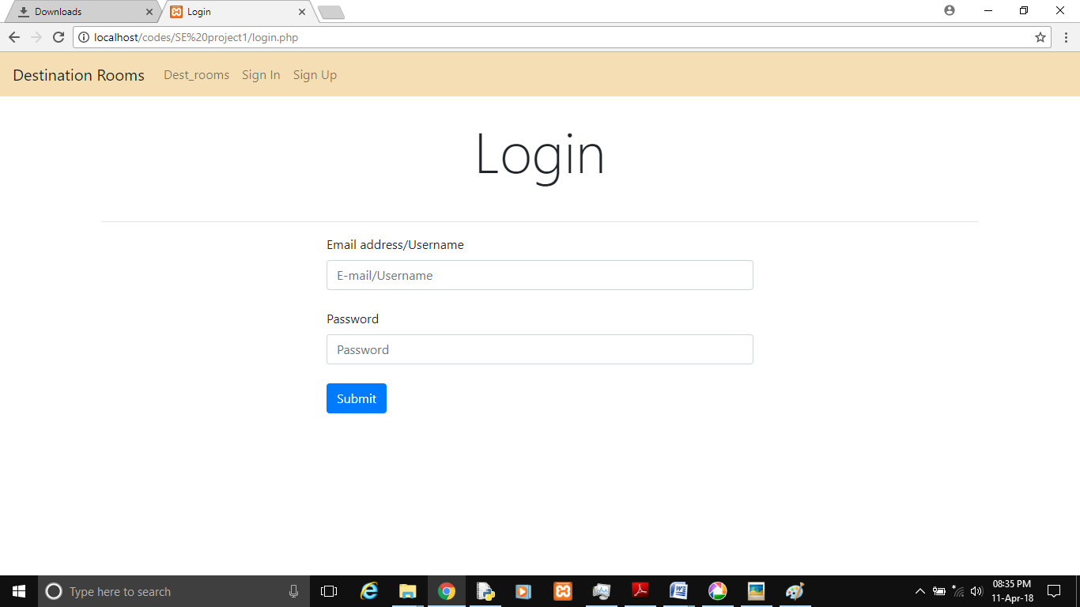

Fig 5.2 Login

5.3 Index.php

<!DOCTYPE html>

<html lang="en">

  <head>

    <!-- Required meta tags -->

    <meta charset="utf-8">

    <meta name="viewport" content="width=device-width, initial-scale=1, shrink-to-fit=no">

    <!-- Bootstrap CSS -->

    <link rel="stylesheet" href="<https://maxcdn.bootstrapcdn.com/bootstrap/4.0.0-alpha.6/css/bootstrap.min.css>" integrity="sha384-rwoIResjU2yc3z8GV/NPeZWAv56rSmLldC3R/AZzGRnGxQQKnKkoFVhFQhNUwEyJ" crossorigin="anonymous">

    <link href="../lightbox/src/css/lightbox.css" rel="stylesheet">

    <script type="text/javascript" src="../lightbox/dist/js/lightbox-plus-jquery.js"></script>

    <script defer src="<https://use.fontawesome.com/releases/v5.0.6/js/all.js>"></script>

<style type="text/css">

  body{

    padding-top: 20px;

  }

  img{

    width: 100%;

    max-height: 400px;

  }

  section{

    padding-bottom: 40px;

  }

  footer{

    margin-top: 15px;

   /* background-color: darkgray;

    border-radius: 20px;

    border:1px solid black;*/

  }

  .circle{

  }

</style>

  </head>

  <body data-spy="scroll" data-target="#mynav">

    <!-- jQuery first, then Tether, then Bootstrap JS. -->

    <script src="<https://code.jquery.com/jquery-3.1.1.slim.min.js>" integrity="sha384-A7FZj7v+d/sdmMqp/nOQwliLvUsJfDHW+k9Omg/a/EheAdgtzNs3hpfag6Ed950n" crossorigin="anonymous"></script>

    <script src="<https://cdnjs.cloudflare.com/ajax/libs/tether/1.4.0/js/tether.min.js>" integrity="sha384-DztdAPBWPRXSA/3eYEEUWrWCy7G5KFbe8fFjk5JAIxUYHKkDx6Qin1DkWx51bBrb" crossorigin="anonymous"></script>

    <script src="<https://maxcdn.bootstrapcdn.com/bootstrap/4.0.0-alpha.6/js/bootstrap.min.js>" integrity="sha384-vBWWzlZJ8ea9aCX4pEW3rVHjgjt7zpkNpZk+02D9phzyeVkE+jo0ieGizqPLForn" crossorigin="anonymous"></script>

<!--Navbar-->

  <nav id="mynav" class="navbar navbar-toggleable-md navbar-inverse bg-inverse fixed-top">

  <button class="navbar-toggler navbar-toggler-right" type="button" data-toggle="collapse" data-target="#navbarSupportedContent" aria-controls="navbarSupportedContent" aria-expanded="false" aria-label="Toggle navigation">

    <span class="navbar-toggler-icon"></span>

  </button>

  <a class="navbar-brand" href="#">Destination Rooms</a>

  <div class="collapse navbar-collapse" id="navbarSupportedContent">

    <ul class="navbar-nav mr-auto">

      <li class="nav-item">

        <a class="nav-link" href="#about">About Us<span class="sr-only">(current)</span></a>

      </li>

      <li class="nav-item">

        <a class="nav-link" href="bookrooms.php">Book Rooms</a>

      </li>

    </ul>

      <ul class="navbar-nav ml-auto">

        <?php

        session_start();

        if(!isset($_SESSION['uname']))

        {

         echo "<li class='nav-item'><a class='nav-link' href='signup.php'>SignUp</a></li><li class='nav-item'><a class='nav-link' href='login.php'>LogIn</a></li>";

        }

        else{

         echo "<form action='login.php' method='POST'><input type='submit' name='logout' class='btn btn-primary' value='Logout'></form>";

        }

      ?>

    </ul>

  </div>

</nav>

<!--Header-->

<div class="container text-center" style="padding-top: 70px;">

<!--About-->

<div class="container" id="about">

  <section>

    <div class="row">

      <div class="col-12">

        <div class="card card-block">

          <h2 class="display-3">About Us</h2>

            <blockquote class="blockquote">

           Destination Rooms- A perfect platform to book hotel's room by just sitting at your home at your favourite location with your affordable facilities.

Every second is precious so as your effort. Therefore we invented this web-application with a free login to every user.

.  <br><br>

            </blockquote>

        </div>

      </div>

    </div>

  </section>

</div>

<!--footer-->

<hr>

<footer id="footer">

  <div class="container text-center">

  <h3 class="display-4">Contact Us</h3>

  <p class="lead">Tel:- 011-25467894</p>

  <p class="lead">Fax:- +91-011-1234567</p>

  <p class="lead">E-mail:- [dest_rooms@oyo.org](mailto:dest_rooms@oyo.org)</p>

  <p class="lead">

   18/A M G Road,New Delhi

  </p>

<hr>

  <p class="display-4">Follow us:-</p>

  <a href="<https://www.twitter.com>"><i class="fab fa-twitter fa-3x"></i></a>

  &nbsp;&nbsp;&nbsp;&nbsp;

  <a href="<https://www.facebook.com>"><i class="fab fa-facebook-f fa-3x"></i></a>

  &nbsp;&nbsp;&nbsp;&nbsp;

  <a href="<https://www.instagram.com>"><i class="fab fa-instagram fa-3x"></i></a>

</div>

<br><hr>

<div class="container-fluid text-center" style="padding: 6px;">

  <h4>Copyright &copy OYO</h4>

</div>

</div>

</footer>

<script src="<https://unpkg.com/scrollreveal/dist/scrollreveal.min.js>"></script>

<script type="text/javascript">

[window.sr](http://window.sr)=ScrollReveal();

  sr.reveal('.navbar',{

    duration:1000,

    mobile:true,

    reset:true,

    delay:50,

    opacity:0,

    origin:'top',

    distance:'400px'

  });

  sr.reveal('#about',{

    duration:1000,

    delay:50,

    mobile:true,

    reset:true,

    opacity:0,

    origin:'left',

    distance:'400px'

  });

    sr.reveal('#footer',{

    duration:1000,

    delay:50,

    mobile:true,

    reset:true,

    opacity:0,

    origin:'right',

    distance:'400px'

  });

</script>

  </body>

</html>

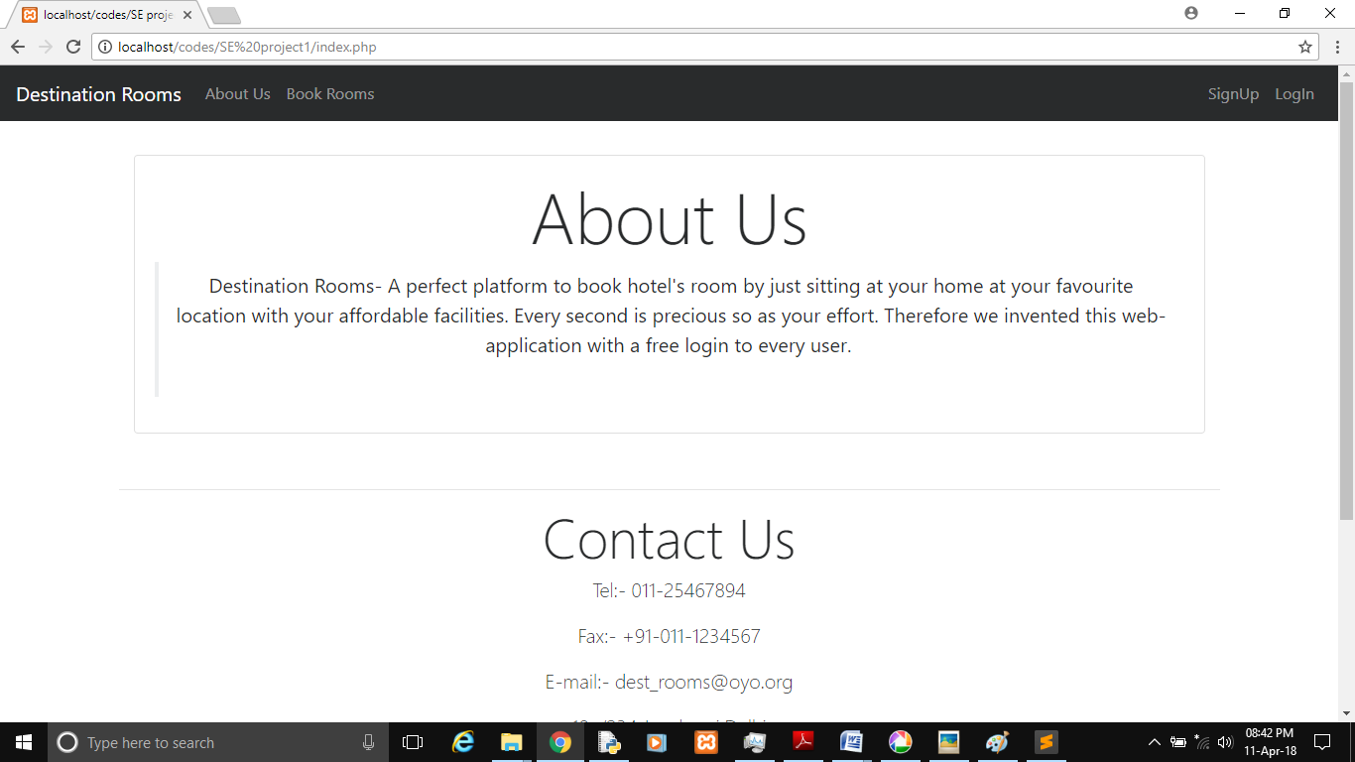

Fig 5.1 First Page

5.4 BookRooms.php

<!DOCTYPE html>

<html lang="en">

<head>

<!-- Required meta tags -->

<?php

session_start();

if(!isset($_SESSION['uname']))

{

header("Location:login.php");

}?>

<meta charset="utf-8">

<meta name="viewport" content="width=device-width, initial-scale=1, shrink-to-fit=no">

<!-- Bootstrap CSS -->

<link rel="stylesheet" href="https://maxcdn.bootstrapcdn.com/bootstrap/4.0.0-alpha.6/css/bootstrap.min.css" integrity="sha384-rwoIResjU2yc3z8GV/NPeZWAv56rSmLldC3R/AZzGRnGxQQKnKkoFVhFQhNUwEyJ" crossorigin="anonymous">

<script defer src="https://use.fontawesome.com/releases/v5.0.6/js/all.js"></script>

<link href="node_modules/@fengyuanchen/datepicker/dist/datepicker.css" rel="stylesheet">

<style type="text/css">

body{

padding-top: 20px;

}

img{

width: 100%;

max-height: 400px;

}

section{

padding-bottom: 40px;

}

footer{

margin-top: 15px;

/* background-color: darkgray;

border-radius: 20px;

border:1px solid black;*/

}

#pa,#pa2{

display: none;

}

</style>

</head>

<body data-spy="scroll" data-target="#mynav">

<!--Navbar-->

<nav id="mynav" class="navbar navbar-toggleable-md navbar-inverse bg-inverse fixed-top">

<button class="navbar-toggler navbar-toggler-right" type="button" data-toggle="collapse" data-target="#navbarSupportedContent" aria-controls="navbarSupportedContent" aria-expanded="false" aria-label="Toggle navigation">

<span class="navbar-toggler-icon"></span>

</button>

<a class="navbar-brand" href="#">Dest_Room</a>

<div class="collapse navbar-collapse" id="navbarSupportedContent">

<ul class="navbar-nav mr-auto">

<li class="nav-item">

<a class="nav-link" href="index.php">About Us<span class="sr-only">(current)</span></a>

</li>

<li class="nav-item">

<a class="nav-link" href="#book">Book Rooms</a>

</li>

</ul>

<ul class="navbar-nav ml-auto">

<li class="nav-item">

<form action="login.php" method="POST">

<input type="submit" name="logout" class="btn btn-primary" value="Logout">

</form>

</li>

</ul>

</div>

</nav>

<!--Header-->

<div class="container text-center" style="padding-top: 70px;" id="book">

<h2 class="display-3">Search For A Nearby Hotel</h2>

<hr><br>

<form action="final.php" onsubmit="return validate()">

<div class="form-group">

<p class="alert alert-danger" id="pa">Please Select A City..!</p>

<p class="alert alert-danger" id="pa2">Enter Valid Dates..!</p>

<label><h3 class="lead">Choose Your Destination Location:-</h3></label>

<div class='col-4 offset-4'>

<select class="form-control" id="location" onchange="change()">

<option value="SC">Select city</option>

<option>Delhi-Connaught Place</option>

<option>Delhi-Rohini</option>

<option>Delhi-Dwarka</option>

<option>Delhi-Janakpuri</option>

</select>

<br>

</div>

<label><h3 class="lead">Select Arrival Date:-</h3></label>

<div class='col-4 offset-4'>

<input data-toggle="datepicker" class="form-control" id="arrival_date" required>

<div data-toggle="datepicker"></div>

</div>

<br>

<label><h3 class="lead">Select Departure Date:-</h3></label>

<div class='col-4 offset-4'>

<input data-toggle="datepicker" class="form-control" id="depart_date" required>

<div data-toggle="datepicker"></div>

</div>

<br>

<button type="submit" class="btn btn-success btn-lg">Submit</button>

</div>

</form>

<!--footer-->

<hr>

<footer id="footer">

<div class="container text-center">

<h3 class="display-4">Contact Us</h3>

<p class="lead">Tel:- 011-25467894</p>

<p class="lead">Fax:- +91-011-1234567</p>

<p class="lead">E-mail:- oyorooms@oyo.org</p>

<p class="lead">

M.G Road 18/A Delhi

</p>

<hr>

<p class="display-4">Follow us:-</p>

<a href="https://www.twitter.com"><i class="fab fa-twitter fa-3x"></i></a>

&nbsp;&nbsp;&nbsp;&nbsp;

<a href="https://www.facebook.com"><i class="fab fa-facebook-f fa-3x"></i></a>

&nbsp;&nbsp;&nbsp;&nbsp;

<a href="https://www.instagram.com"><i class="fab fa-instagram fa-3x"></i></a>

</div>

<br><hr>

<div class="container-fluid text-center" style="padding: 6px;">

<h4>Copyright &copy Dest_room</h4>

</div>

</div>

</footer>

<!-- jQuery first, then Tether, then Bootstrap JS. -->

<script src="https://code.jquery.com/jquery-3.3.1.js" integrity="sha256-2Kok7MbOyxpgUVvAk/HJ2jigOSYS2auK4Pfzbm7uH60=" crossorigin="anonymous"></script>

<script src="node_modules/@fengyuanchen/datepicker/dist/datepicker.js"></script>

<script src="https://cdnjs.cloudflare.com/ajax/libs/tether/1.4.0/js/tether.min.js" integrity="sha384-DztdAPBWPRXSA/3eYEEUWrWCy7G5KFbe8fFjk5JAIxUYHKkDx6Qin1DkWx51bBrb" crossorigin="anonymous"></script>

<script src="https://maxcdn.bootstrapcdn.com/bootstrap/4.0.0-alpha.6/js/bootstrap.min.js" integrity="sha384-vBWWzlZJ8ea9aCX4pEW3rVHjgjt7zpkNpZk+02D9phzyeVkE+jo0ieGizqPLForn" crossorigin="anonymous"></script>

<script src="https://unpkg.com/scrollreveal/dist/scrollreveal.min.js"></script>

<script type="text/javascript">

window.sr=ScrollReveal();

sr.reveal('.navbar',{

duration:1000,

mobile:true,

reset:true,

delay:50,

opacity:0,

origin:'top',

distance:'400px'

});

sr.reveal('#footer',{

duration:1000,

delay:50,

mobile:true,

reset:true,

opacity:0,

origin:'bottom',

distance:'400px'

});

sr.reveal('#book',{

duration:1000,

delay:50,

mobile:true,

reset:true,

opacity:0,

origin:'left',

distance:'400px'

});

function change(){

var location=document.getElementById('location');

var invalid=location.value=='SC';

if (invalid) {

$('#pa').css('display','block');

return false;

}

else{

$('#pa').css('display','none');

return true;

}

}

function date_valid(){

var arrival_date=document.getElementById('arrival_date').value;

var depart_date=document.getElementById('depart_date').value;

if (depart_date<arrival_date) {

$('#pa2').css('display','block');

return false;

}

else{

$('#pa2').css('display','none');

return true;

}

}

function validate(){

var c=change();

var d=date_valid();

//alert(c);alert(d);

var a=c&&d;

return a;

}

$('[data-toggle="datepicker"]').datepicker();

</script>

</body>

</html>

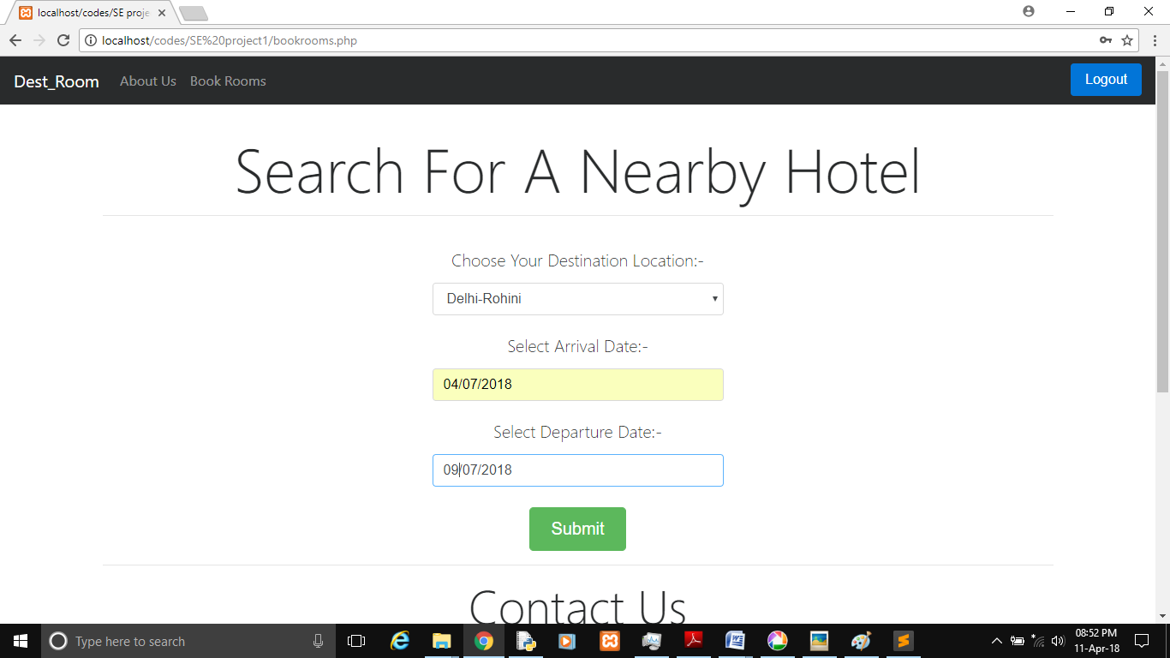

**Fig 5.3.2 Book Rooms**

5.5 Final.php

<!DOCTYPE html>

<html lang="en">

<head>

<?php

session_start();

if(!isset($_SESSION['uname']))

{

header("Location:login.php");

}

?>

<!-- Required meta tags -->

<meta charset="utf-8">

<meta name="viewport" content="width=device-width, initial-scale=1, shrink-to-fit=no">

<!-- Bootstrap CSS -->

<link rel="stylesheet" href="https://maxcdn.bootstrapcdn.com/bootstrap/4.0.0-alpha.6/css/bootstrap.min.css" integrity="sha384-rwoIResjU2yc3z8GV/NPeZWAv56rSmLldC3R/AZzGRnGxQQKnKkoFVhFQhNUwEyJ" crossorigin="anonymous">

<link href="../lightbox/src/css/lightbox.css" rel="stylesheet">

<script type="text/javascript" src="../lightbox/dist/js/lightbox-plus-jquery.js"></script>

<link rel="stylesheet" href="https://use.fontawesome.com/releases/v5.0.9/css/all.css" integrity="sha384-5SOiIsAziJl6AWe0HWRKTXlfcSHKmYV4RBF18PPJ173Kzn7jzMyFuTtk8JA7QQG1" crossorigin="anonymous">

<style type="text/css">

body{

padding-top: 20px;

}

img{

width: 100%;

max-height: 400px;

}

section{

padding-bottom: 40px;

}

footer{

margin-top: 15px;

/* background-color: darkgray;

border-radius: 20px;

border:1px solid black;*/

}

#err1,#err2,#err3,#book1,#book2,#book3{

display: none;

}

</style>

</head>

<body data-spy="scroll" data-target="#mynav">

<!-- jQuery first, then Tether, then Bootstrap JS. -->

<script src="https://code.jquery.com/jquery-3.1.1.slim.min.js" integrity="sha384-A7FZj7v+d/sdmMqp/nOQwliLvUsJfDHW+k9Omg/a/EheAdgtzNs3hpfag6Ed950n" crossorigin="anonymous"></script>

<script src="https://cdnjs.cloudflare.com/ajax/libs/tether/1.4.0/js/tether.min.js" integrity="sha384-DztdAPBWPRXSA/3eYEEUWrWCy7G5KFbe8fFjk5JAIxUYHKkDx6Qin1DkWx51bBrb" crossorigin="anonymous"></script>

<script src="https://maxcdn.bootstrapcdn.com/bootstrap/4.0.0-alpha.6/js/bootstrap.min.js" integrity="sha384-vBWWzlZJ8ea9aCX4pEW3rVHjgjt7zpkNpZk+02D9phzyeVkE+jo0ieGizqPLForn" crossorigin="anonymous"></script>

<!--Navbar-->

<nav id="mynav" class="navbar navbar-toggleable-md navbar-inverse bg-inverse fixed-top">

<button class="navbar-toggler navbar-toggler-right" type="button" data-toggle="collapse" data-target="#navbarSupportedContent" aria-controls="navbarSupportedContent" aria-expanded="false" aria-label="Toggle navigation">

<span class="navbar-toggler-icon"></span>

</button>

<a class="navbar-brand" href="#">Dest_Rooms</a>

<div class="collapse navbar-collapse" id="navbarSupportedContent">

<ul class="navbar-nav mr-auto">

<li class="nav-item">

<a class="nav-link" href="index.php">About Us<span class="sr-only">(current)</span></a>

</li>

<li class="nav-item">

<a class="nav-link" href="bookrooms.php">Book Rooms</a>

</li>

</ul>

<ul class="navbar-nav ml-auto">

<li class="nav-item">

<form action="login.php" method="POST">

<input type="submit" name="logout" class="btn btn-primary" value="Logout">

</form>

</li>

</ul>

</div>

</nav>

<!--Header-->

<div class="container text-center" style="padding-top: 70px;">

<div class="head1">

<h3 class="display-4">Select A Nearby Hotel</h3>

<p class="lead">(3 Nearby Hotels Found)</p>

<hr>

<div id="accordian" role="tablist">

<div class="row">

<div class="col-md-4 col-12">

<div class="card">

<a href="#download" class="btn btn-primary" data-toggle="collapse" data-parent="#accordian">Hotel Le Paradise</a>

<div class="collapse" id="download">

<div class="card card-block">

<img src="img/1.jpg" class="card-img-top img-fluid img-thumbnail">

<h2>Hotel Le Paradise</h2>

<p class="lead">Lorem ipsum dolor sit amet, consectetur adipisicing elit, sed do eiusmod

tempor incididunt ut labore et dolore magna aliqua. Ut enim ad minim veniam,

quis nostrud exercitation ullamco laboris nisi ut aliquip ex ea commodo

consequat. Duis aute irure dolor in reprehenderit in voluptate velit esse

cillum dolore eu fugiat nulla pariatur. Excepteur sint occaecat cupidatat non

proident, sunt i</p>

<div class="row align-items-center">

<div class="col-6 text-right">

<p id="one" class="lead">1</p>

</div>

<div class="col-6">

<div class="row text-left">

<div class="col-12">

<i class="fas fa-plus" id="addone"></i>

</div>

</div>

<div class="row text-left">

<div class="col-12">

<i class="fas fa-minus" id="subone"></i>

</div>

</div>

</div>

</div>

<a href="#" class="btn btn-primary" onclick="book1()">Book Rooms</a>

<br>

<div class="alert alert-success" id="book1">SuccessFully Booked Your Rooms..!</div>

<div class="alert alert-danger" id="err1">You can select rooms in range(1-5){Minimum:1,Maximum:5}</div>

</div>

</div>

</div></div>

<div class="col-md-4 col-12">

<div class="card">

<a href="#contact" class="btn btn-success" data-toggle="collapse" data-parent="#accordian">Hotel-The Indian</a>

<div class="collapse" id="contact">

<div class="card card-block">

<img src="img/2.jpg" class="card-img-top img-fluid img-thumbnail">

<h2>Hotel-The Indian</h2>

<p class="lead">Lorem ipsum dolor sit amet, consectetur adipisicing elit, sed do eiusmod

tempor incididunt ut labore et dolore magna aliqua. Ut enim ad minim veniam,

quis nostrud exercitation ullamco laboris nisi ut aliquip ex ea commodo

consequat. Duis aute irure dolor in reprehenderit in voluptate velit esse

cillum dolore eu fugiat nulla pariatur. Excepteur sint occaecat cupidatat non

proident, sunt i</p>

<div class="row align-items-center">

<div class="col-6 text-right">

<p id="two" class="lead">1</p>

</div>

<div class="col-6">

<div class="row text-left">

<div class="col-12">

<i class="fas fa-plus" id="addtwo"></i>

</div>

</div>

<div class="row text-left">

<div class="col-12">

<i class="fas fa-minus" id="subtwo"></i>

</div>

</div>

</div>

</div>

<a href="#" class="btn btn-success" onclick="book2()">Book Rooms</a><br>

<div class="alert alert-success" id="book2">SuccessFully Booked Your Rooms..!</div>

<div class="alert alert-danger" id="err2">You can select rooms in range(1-5){Minimum:1,Maximum:5}</div>

</div>

</div>

</div> </div>

<div class="col-md-4 col-12">

<div class="card">

<a href="#support" class="btn btn-warning" data-toggle="collapse" data-parent="#accordian">Radission Blu</a>

<div class="collapse" id="support">

<div class="card card-block">

<img src="img/3.jpg" class="card-img-top img-fluid img-thumbnail">

<h2>Radission Blu</h2>

<p class="lead">Lorem ipsum dolor sit amet, consectetur adipisicing elit, sed do eiusmod

tempor incididunt ut labore et dolore magna aliqua. Ut enim ad minim veniam,

quis nostrud exercitation ullamco laboris nisi ut aliquip ex ea commodo

consequat. Duis aute irure dolor in reprehenderit in voluptate velit esse

cillum dolore eu fugiat nulla pariatur. Excepteur sint occaecat cupidatat non

proident, sunt i</p>

<hr>

<div class="row align-items-center">

<div class="col-6 text-right">

<p id="three" class="lead">1</p>

</div>

<div class="col-6">

<div class="row text-left">

<div class="col-12">

<i class="fas fa-plus" id="addthree"></i>

</div>

</div>

<div class="row text-left">

<div class="col-12">

<i class="fas fa-minus" id="subthree"></i>

</div>

</div>

</div>

</div> <a href="#" class="btn btn-warning" onclick="book3()">Book Rooms</a><br>

<div class="alert alert-success" id="book3">SuccessFully Booked Your Rooms..!</div>

<div class="alert alert-danger" id="err3">You can select rooms in range(1-5){Minimum:1,Maximum:5}</div>

</div>

</div>

</div>

</div>

</div>

</div>

</div><br><br>

<div class="row">

<div class="col-md-8 abt">

<h3 class="display-4">We Provide Best In Class Services</h3><hr>

<blockquote class="blockquote">

Destination Rooms- A perfect platform to book hotel's room by just sitting at your home at your favourite location with your affordable facilities. Every second is precious so as your effort. Therefore we invented this web-application with a free login to every user.

<br><br>

</blockquote>

</div>

<div class="col-md-4 frm">

<form>

<div class="form-group" style="border: 1px solid green;border-radius: 5px; padding: 25px; box-sizing: border-box; box-shadow: 10px 10px 35px green;">

<h3 class="display-4">Feedback</h3><br>

<div class="row">

<div class="col-4">

<label for="name">Name:</label>

</div>

<div class="col-8">

<input type="text" class="form-control" name="name" required><br>

</div>

</div>

<div class="row">

<div class="col-4">

<label for="email">E-mail:</label>

</div>

<div class="col-8">

<input type="text" class="form-control" name="email" required><br>

</div>

</div>

<div class="row">

<div class="col-4">

<label for="body">Message:</label>

</div>

<div class="col-8">

<input type="textarea" class="form-control" name="body" required><br>

</div>

</div>

<a href="#" class="btn btn-success">Submit</a>

</div>

</form>

</div>

</div>

</div>

<!--footer-->

<hr>

<footer id="footer">

<div class="container text-center">

<h3 class="display-4">Contact Us</h3>

<p class="lead">Tel:- 011-25467894</p>

<p class="lead">Fax:- +91-011-1234567</p>

<p class="lead">E-mail:- dest_rooms@oyo.org</p>

<p class="lead">

M.G Road 18/A ,Delhi

</p>

<hr>

<p class="display-4">Follow us:-</p>

<a href="https://www.twitter.com"><i class="fab fa-twitter fa-3x"></i></a>

&nbsp;&nbsp;&nbsp;&nbsp;

<a href="https://www.facebook.com"><i class="fab fa-facebook-f fa-3x"></i></a>

&nbsp;&nbsp;&nbsp;&nbsp;

<a href="https://www.instagram.com"><i class="fab fa-instagram fa-3x"></i></a>

</div>

<br><hr>

<div class="container-fluid text-center" style="padding: 6px;">

<h4>Copyright &copy Dest_rooms</h4>

</div>

</div>

</footer>

<script src="https://unpkg.com/scrollreveal/dist/scrollreveal.min.js"></script>

<script type="text/javascript">

window.sr=ScrollReveal();

sr.reveal('.navbar',{

duration:1000,

mobile:true,

reset:true,

delay:50,

opacity:0,

origin:'top',

distance:'400px'

});

sr.reveal('#footer',{

duration:1000,

delay:50,

mobile:true,

reset:true,

opacity:0,

origin:'bottom',

distance:'400px'

});

sr.reveal('.head1',{

duration:1000,

delay:50,

mobile:true,

reset:true,

opacity:0,

origin:'bottom',

distance:'400px'

});

sr.reveal('.abt',{

duration:1000,

delay:50,

mobile:true,

reset:true,

opacity:0,

origin:'left',

distance:'400px'

});

sr.reveal('.frm',{

duration:1000,

delay:500,

mobile:true,

reset:true,

opacity:0,

origin:'right',

distance:'400px'

});

var count1=1;

var count2=1;

var count3=1;

$('#addone').on('click',()=>{

count1++;

if (count1>=6) {

alert("You can not add more than 5 rooms");

$('#err1').css('display','block');

}

else

{

$('#err1').css('display','none');

document.getElementById('one').innerHTML = count1;

}

});

$('#subone').on('click',()=>{

count1--;

if (count1<=0) {

alert("You can not Select 0 rooms");

$('#err1').css('display','block');

}

else

{

$('#err1').css('display','none');

document.getElementById('one').innerHTML = count1;

}

});

$('#addtwo').on('click',()=>{

count2++;

if (count2>=6) {

alert("You can not add more than 5 rooms");

$('#err2').css('display','block');

}

else

{

$('#err2').css('display','none');

document.getElementById('two').innerHTML = count2;

}

});

$('#subtwo').on('click',()=>{

count2--;

if (count2<=0) {

alert("You can not Select 0 rooms");

$('#err2').css('display','block');

}

else

{ $('#err2').css('display','none');

document.getElementById('two').innerHTML = count2;

}

});

$('#addthree').on('click',()=>{

count3++;

if (count3>=6) {

alert("You can not add more than 5 rooms");

$('#err3').css('display','block');

}

else

{

$('#err3').css('display','none');

document.getElementById('three').innerHTML = count3;

}

});

$('#subthree').on('click',()=>{

count3--;

if (count3<=0) {

alert("You can not Select 0 rooms");

$('#err3').css('display','block');

}

else

{ $('#err3').css('display','none');

document.getElementById('three').innerHTML = count3;

}

});

function book1(){

alert('Your Rooms are Booked..!!');

$('#book1').css('display','block');

}

function book2(){

alert('Your Rooms are Booked..!!');

$('#book2').css('display','block');

}

function book3(){

alert('Your Rooms are Booked..!!');

$('#book3').css('display','block');

}

</script>

</body>

</html>

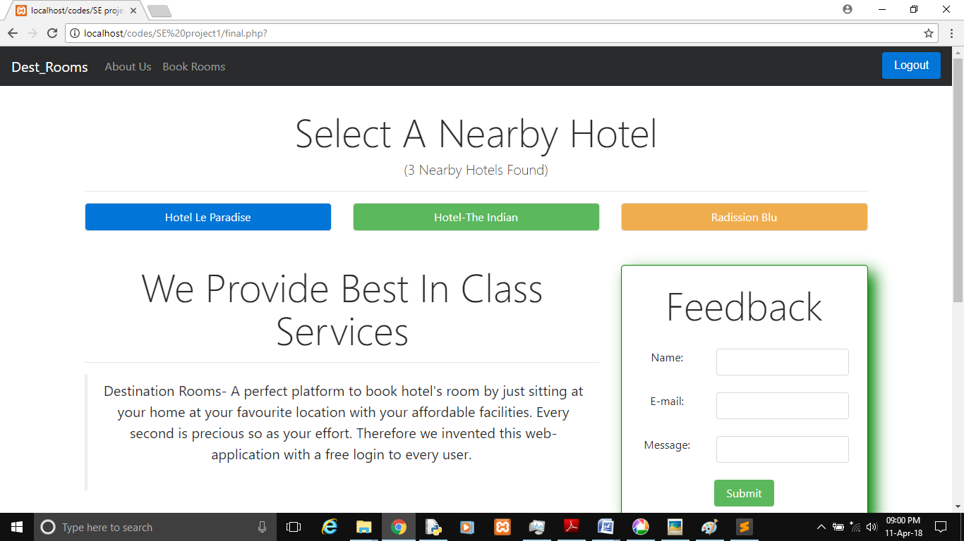

Fig 5.4 Home Page

6.**Testing**

**6.1** White Box Testing:

**White-box testing** (also known as **clear box testing**, **glass box testing**, **transparent box testing**, and **structural testing**) is a method of testing software that tests internal structures or workings of an application, as opposed to its functionality (i.e. black-box testing). In white-box testing an internal perspective of the system, as well as programming skills, are used to design test cases. The tester chooses inputs to exercise paths through the code and determine the expected outputs.

**6.1.1 Basis Path Testing:**

Basis path testing is a testing technique used for designing test cases intended to examine all possible paths of execution at least once. Creating and executing tests for all possible paths results in 100% statement coverage and 100% branch coverage.

**Cyclomatic Complexity:**

Cyclomatic complexity is a source code complexity measurement that is being correlated to a no. of coding errors. It is calculated by developing a program flow graph of source code that measures the no. of independent paths through the program module.

**Source code for testing**

<?php

session_start();

if(!isset($_SESSION['uname']))

{

echo "<li class='nav-item'><a class='nav-link' href='signup.php'>SignUp</a></li><li class='nav-item'><a class='nav-link' href='login.php'>LogIn</a></li>";

}

else{

echo "<form action='login.php' method='POST'><input type='submit' name='logout' class='btn btn-primary' value='Logout'></form>";

}

?> 6.2 Program Flow Graph**:**

**Cyclomatic Complexity:**

**edges-nodes+2**

**4-4+2=0**

**Fig 6.2.1 Program Flow Graph**

**6.3 Independent Paths:**

**1. a->b->d**

**2. a->c->d**

Source Code for testing

<?php

if(isset($_POST['logout'])){

session_destroy();

header("Location:login.php");

}

else if(isset($_SESSION['uname'])){

header('Location: bookrooms.php');

}

if(isset($_POST['btn']))

{

if(isset($_POST['uname'])&&!empty($_POST['uname'])&&isset($_POST['pwd'])&&!empty($_POST['pwd']))

{

$f=0;

$u=$_POST['uname'];

$p=$_POST['pwd'];

$handle=fopen("user_crs.txt","r");

while(!feof($handle))

{

$s=fgets($handle);

$a=explode(':',$s);

if(($u==trim($a[0])) &&($p==trim($a[1])))

{

$f=1;

$_SESSION['uname']=$u;

echo "<br><div class='container'><div class='alert alert-success'>Welcome to your account</div></div>";

header('Location: bookrooms.php');

}

}

if($f==0){

echo "<br><div class='container'><div class='alert alert-danger'>Invalid Username/Password</div></div>";

}

fclose($handle);}

**Program Flow Graph:**

**Cyclomatic Complexity:**

**edges-nodes+2**

39-34+2 = 7

**Fig 6.2.2 Program Flow Graph**

Independent Paths:

(a) 1->2->6->9->34

(b) 1->2->6->7->8->9->34

(c) 1->2->6->7->8->9->10->11->33->34

(d) 1->2->6->7->8->9->10->11->12->13->14->15->16->17->28->29->32->33->34

(e) 1->2->3->4->5->9->34

(f) 1->2->3->4->5->9->10->11->34

(g) 1->2->6->7->8->9->10->11->12->13->14->15->16->17->28->29->30->31->32->33->33->34

**Source code for testing**

<?php

if(isset($_POST['btn2']))

{

if(isset($_POST['uname'])&&!empty($_POST['uname'])&&isset($_POST['pwd'])&&!empty($_POST['pwd']))

{

$u=$_POST['uname'];

$p=$_POST['pwd'];

$f=1;

$str="\n".$u.":".$p;

$handle=fopen("user_crs.txt","a+");

while(!feof($handle))

{

$s=fgets($handle);

$a=explode(':',$s);

if(($u==trim($a[0])))

{

$f=0;

echo "<br><div class='container'><div class='alert alert-danger'>Email Already in Use..Try Again</div></div>";

break;

}

}

if($f==1)

{

fwrite($handle,$str);

header("Location:login.php");

}

fclose($handle);

}

}

?>

**Program Flow Graph: Cyclomatic Complexity:**

edges-nodes+2

33-30+2 = 5

**Fig 6.2.3 Program Flow Graph**

Independent Paths:

a)**1->2->29->30**

**b)1->2->3->4->28->29->30**

**c)1->2->3->4->5->6->7->8->9->10->11->22->27->28->29->30**

**d)1->2->3->4->5->6->7->8->9->10->11->22->23->24->25->26->27->28->29->30**

**e)1->2->3->4->5->6->7->8->9->10->11->12->13->14->15->21->22-> 28->29->30**

**7. User Manual**

**Destination Room- An Online Hotel Booking System**

The User Manual explains us the step by step procedure to set up and use the Destination Rooms- An Online Hotel Room Booking System web application.

1. New User should signup in order to use the system or Existing User can login. Hence stable internet connection is required.
2. User must select the hotel location where he wants to stay.
3. User must select the arrival and departure date of stay.
4. Now a set of hotel will be displayed in the selected location. From which user can choose any and enter number of rooms to be booked (max 5 from one user id).
5. Now user will be directed to screen where Booking summary is showed and user can make payment using payment gateway.
6. After booking is confirmed, user will receive a message of confirmation.
7. Now user can logout from the system and can use the above steps for future bookings.
8. **Conclusion**

The entire project has been developed and deployed as per the requirements stated by the user. It is found to be bug free as per the testing standards that are implemented.

The whole system’s activities are divided into two major parts like user and admin. For implementing the system PHP, Java Script and other coding languages has been used.

The system comprises of following features:

* Hotel search at user’s desired location.
* Different types of room booking according to user’s demands.
* Generating confirmation and payment receipt after booking.

The estimated cost of the project is 2.38 (efforts) and the estimated size of the project is 114 (FP).

T

There are also few features which can be integrated with this system to make it more flexible. Below list shows the future points to be consider:

* Cab booking service for pick-up and drop.
* Hiring of guide for exploring the city.

Finally, we like to conclude that we put all our efforts throughout the development of our project and tried to fulfill every requirement of the user*.*

References

[1] R.S.Pressman,Software Engineering,McGraw-Hill,Ed 7,2010.

[2] P.Jalote, An Integrated Approch to Software Engineering,Ed.3,2011.

[3] Elmasri Navathe, *Fundamentals of Database System 3rd edition*. Pearson education,2000.

[4] Bootstrap and other media/language files from [www.getbootsrap.com](http://www.getbootsrap.com)

[5] Learning PHP, MySQL & JavaScript with jQuery, CSS & HTML5 (4th ed.)